**WOMENS’S W.O.R.K.**

[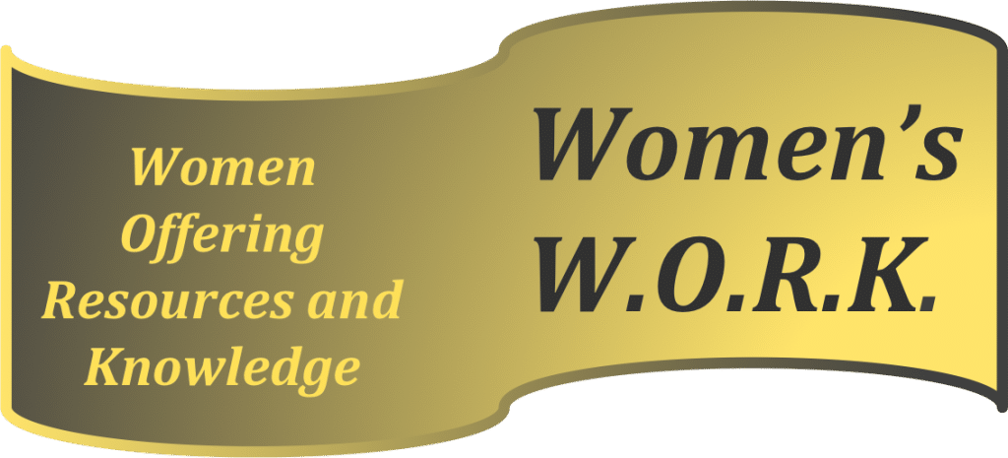](https://www.canadahelps.org/en/charities/womens-work-women-offering-resources-knowledge/)

**Women’s W.O.R.K. (Women Offering Resources and Knowledge)** is a charitable organization with the objective of providing funding to support seminars/workshops/projects sponsored through BPW clubs across Canada. These events, open to the public, must be specifically centred on helping women increase their knowledge in areas that will help them to become successful in business and politics and to provide information on issues specific to women.

Donating to **Women’s W.O.R.K.** is a tax-efficient way to support BPW through personal or [**“in memoriam”**](https://bpwcanada.com/bpw-membership/bpw-canada-in-memoriam/)contributions as BPW Canada is not a registered charity. **Women’s W.O.R.K.** is registered with the Canada Revenue Agency.

Your contribution to **Women’s** **W.O.R.K.** will allow the fund to grow and thus generate funding for [**BPW Clubs**](https://bpwcanada.com/bpw-membership/find-a-club.html) to apply for funds to assist in putting on seminars by their clubs for the benefit of the members and public.

Please consider **Women’s** **W.O.R.K**. when recognizing co-workers and other associates by making annual donations or as a specific beneficiary of your personal estate. 

**DONATIONS:**

**Donation cheques:** payable to **Women’s W.O.R.K.** can be mailed to:

Women’s W.O.R.K. Treasurer

1851 Sandy Somerville Lane,

London, Ontario N6K 5R4

**Donations via credit card or PayPal**: through [**www.canadahelps.org**](https://www.canadahelps.org/en/charities/womens-work-women-offering-resources-knowledge/)resulting in an immediate tax receipt and also provides the option of sending a virtual card.

**BPW Canada Members: Application form and information:**[**login**](https://bpwcanada.com/member-login/)**to the Members Area of the website and go to the Women’s W.O.R.K. page.  NOTE: Application deadline is 2 months prior to the event!**