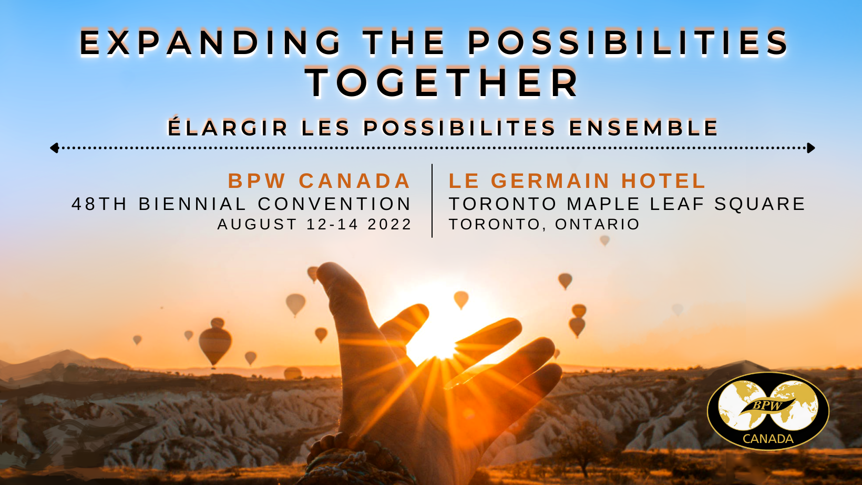

SPONSORSHIP OPPORTUNITY

BPW Member: Norma Yau,
BPW Canada 2022 National Convention Sponsorship Chair
communications@bpwcanada.com
www.bpwcanada.com
PRESIDENT’S MESSAGE
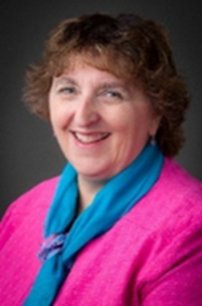

Greetings from the Canadian Federation of Business and Professional Women (BPW Canada). BPW Canada is a non-sectarian, non-profit, and non-partisan organization that works to improve the economic, political, social and employment conditions of working women in Canada. BPW Canada was founded in 1930 and was one of the Founding Federations of the International Federation of Business and Professional Women.
I am excited to be talking about the 2022 BPW Canada Convention to be taking place at Le Germain Hotel Maple Leaf Square August 12 – 14, 2022. Our membership has not been able to meet in person since 2019, and while we have completed all of our business virtually during this time, it definitely is not the same. We expect strong representation of members coming to the Convention from our clubs from coast to coast, from Langley, British Columbia to Moncton, New Brunswick.
Your sponsorship is very much appreciated as BPW Canada works hard to put together an amazing event. We will be offering Speakers and Workshops to help our members do the work of our Pillars – “Learn, Collaborate, Advocate and Lead”. Your sponsorship will be a key part of us “Expanding the Possibilities-Together”.
Thank you!!

Karin Gorgerat President 2020-2022

WHO WE ARE
In her President’s message, Karin introduced The Canadian Federation of Business and Professional Women (BPW Canada). We provide a training ground for developing professional, business and leadership potential in a safe and supportive environment, enabling members to build skills, networks and create lasting friendships.
BPW Canada was founded in 1930, the same year as the International Federation of Business and Professional Women (BPW International) and is one of BPW International's Founding Federations. BPW International and just this year BPW Canada has Consultative Status at the United Nations Economic and Social Council (ECOSOC) and now includes affiliates in more than 100 countries around the world. Membership in a local club includes membership in the provincial, national and international Federations thereby encouraging participation at any and all levels and events.

Our Mission
BPW develops the business, professional and leadership potential of women on all levels through advocacy, education, mentoring, networking, skill-building, and economic empowerment programs and projects across Canada and around the world.

Our Goal
To improve the economic, political, social and employment conditions for women in Canada. Bottom line, we work to educate and empower women in Canada.

Convention Highlights
BPW Canada has recently been the recipient along with CCEW (Canadian Coalition to Empower Women) of a federal grant for a Gender Equality Project that will also focus on COVID recovery for women. The initial launch event is planned for the first day of the national conference.
We are extremely excited to be finalizing our diverse, dynamic speakers for the Convention. They include the OPSEU Director of the Indigenous Circle, Vice President of the Canadian Labour Congress, President of the Toronto Chapter of Blacks in Technology Foundation, a Managing Director for Champions for Change, and President of one of Canada's leading full-service apparel manufacturers.
BPW CANADA INITIATIVES AND PROGRAMS AND PARTNERSHIPS
- BPW Canada supports the UN Women and UN Global Compact Women's Empowerment Principles (WEPs) and encourages the awareness, promotion and integration of the Women's Empowerment Principles into all aspects of Canadian life; including small business, all levels of government and civil society

- BPW International took on the 2030 Agenda for Sustainable Development as it’s triennial theme from 2017 to 2020, and BPW Canada with all its member clubs continues to keep all aspects of the SDGs in mind when starts their initiatives, programs, events and partnerships. 17 SDG's to Change the World (bpwcanada.com)

- Participation in Equal Pay Days activities yearly and encouragement to individual BPW clubs across Canada to request their provincial and local leaders to recognize Equal Pay Day

- #ProjectMaple Leaf – partnership with the Courage For Freedom organization on a Canada-wide campaign started in 2019 in Ontario to emphasize the issue of Human Trafficking ( PROJECTMAPLELEAF (courageforfreedom.org) )

- Mentoring and training BPW members on delegate conduct and requirements for the NGO CSW Commission on the Status of Women | UN Women yearly event (in 2022 this event will be held virtually for many delegates between March 14 – 25). BPW Canada received Special Consultative Status for CSW in 2021.

Suggestions:
Gala Speaker: $2500
Event Speaker: $1000
Breaks: $500 each up to 3 breaks available for sponsorship
Support an Attendee: amount as designated by sponsor (registration fee, hotel room and transportation could approximate $1000 or more)
Supplier Costs: AV, printed materials, photographer, transportation

SUPPORT A BPW MEMBER OR A WOMAN FROM YOUR WORK OR PERSONAL COMMUNITY

A special emphasis that we hope will encourage, finance, and assist those members, especially Young BPW members, who are not able to, for any reason, attend the 2022 BPW Canada National Convention in person. An opportunity for a business/company to introduce their employees to BPW. The attendee will be provided with a special name tag that will indicate her sponsor.

Consider sponsoring the following possibilities:

A Young BPW member (one who is 35 years or under)

A BPW member who has never attended Convention previously

One of our speakers (Note: these speakers may not attend the whole Convention)

A woman from your company who is interested in making a difference

A woman whom you are mentoring

A woman who is interested in the Cornerstones of BPW – Learning (personal and professional development), Collaborating (supportive networking), Advocacy (awareness and presentation of women’s issues to various levels of governments), and Lead (leadership development and opportunities).

A woman from another area of the country who would be interested in attending the conference and whom you would like to support/meet

OUR THANK YOU TO YOU

Recognition Levels
Outstanding and Extraordinary Possibilities - $5,000+
- NAMING SPONSOR FOR AN EVENT SPEAKER OR SESSION OF YOUR CHOICE
- EXHIBITOR/SPONSOR SPACE
- NETWORKING WITH PARTICIPANTS
- TICKETS TO GALA BANQUET FOR 2 – SPECIAL SEATING
- TICKETS TO FRIDAY EVENING SOCIAL FOR 2
- NAME ON THE TOP OF THE SPONSOR SIGNAGE AT THE CONVENTION
- NAME ON CONVENTION COMMUNICATIONS
- FOUR BRANDED ANNOUNCEMENTS
- SESSION PRE-ROLL VIDEO MESSAGING
- BRANDING ON AGENDA
- BPW CANADA WEBSITE AND SOCIAL MEDIA POSTINGS PRIOR TO AND AFTER THE CONVENTION
Extraordinary Possibilities - $2500+
- NAMING SPONSOR FOR AN EVENT SPEAKER OR SESSION OF YOUR CHOICE
- EXHIBITOR/SPONSOR SPACE
- NETWORKING WITH PARTICIPANTS
- TICKETS TO GALA BANQUET FOR 2
- NAME ON THE TOP OF THE SPONSOR SIGNAGE AT THE CONVENTION
- NAME ON CONVENTION COMMUNICATIONS
- THREE BRANDED ANNOUNCEMENTS
- SESSION PRE-ROLL VIDEO MESSAGING
- BRANDING ON AGENDA
- BPW CANADA WEBSITE AND SOCIAL MEDIA POSTINGS PRIOR TO AND AFTER THE CONVENTION
Expanded Possibilities - $1000+
- NAMING SPONSOR FOR AN EVENT SPEAKER OR EVENT LOCATION
- EXHIBITOR/SPONSOR SPACE
- NETWORKING WITH PARTICIPANTS
- NAME ON THE 2ND TIER OF THE SPONSOR SIGNAGE AT THE CONVENTION
- NAME ON CONVENTION COMMUNICATIONS
- TWO BRANDED ANNOUNCEMENTS
- BRANDING ON AGENDA
- BPW CANADA WEBSITE AND SOCIAL MEDIA POSTINGS PRIOR TO AND AFTER THE CONVENTION

New Possibilities - $500+
- EXHIBITOR/SPONSOR SPACE
- NETWORKING WITH PARTICIPANTS
- NAME ON 3RD TIER OF THE SPONSOR SIGNAGE AT THE CONVENTION
- NAME ON CONVENTION COMMUNICATIONS
- ONE BRANDED ANNOUNCEMENT
- BRANDING ON THE AGENDA
- BPW CANADA WEBSITE AND SOCIAL MEDIA POSTINGS PRIOR TO AND AFTER THE CONVENTION
Possibilities – Under $500
- SPONSOR SPACE
- NETWORKING WITH PARTICIPANTS
- NAME ON SPONSOR SIGNAGE AT THE CONFERENCE
- BRANDING ON THE AGENDA

“Hope just means another world might be possible, not promise, not guaranteed. Hope calls for action; action is impossible without hope.” – Rebecca Solnit
Rebecca Solnit is an American writer. She has written on a variety of subjects, including feminism, the environment, politics, place, and art.

